

Up. Time SSL Certificate Expiry Check

Executive Summary
Prerequisites
Installation
Troubleshooting

Doc Rev 1.0 – Tuesday November 18th 2008
Author: Kenneth Cheung – Solutions Engineering
ken.cheung@uptimesoftware.com

Executive Summary

This document provides a detailed overview of how to get the SSL Certificate Expiry Monitor for up.time installed and configured.

The purpose of the monitor is to interact with an SSL website, extract the expiry date of the certificate used to secure the URL, and to determine how many days are left till expiry so that up.time can alert if there are only a certain number of days left (configurable by the user)

Metric | Metric Description
Expiry days | Number of days remaining until the certificate expires. (Negatives indicate how many days the certificate has been expired for)

The document will also outline how to enable the required CURL libraries in PHP.

Prerequisites

The following must be enabled for your instance of PHP
- LIB CURL

Enabling CURL

To enable mod status edit your php.ini and uncomment the following line by removing the semicolon from the front:

;extension=php_curl.dll

It should now read:

extension=php_curl.dll

Where to find the php.ini

The uptime monitoring station installs an instance of PHP on your system. For example in windows based operating systems the PHP instance would be found in :

C:\Program Files\uptime software\uptime4\apache\php

Installation
Before you proceed with installation please note the following directory structure for the compressed plugin files that you download :

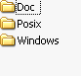

The doc folder contains this document.
The POSIX folder contains all the scripts necessary to install this plug-in for your respective up.time Monitoring Station operating system.

Please determine which type of monitor architecture you will be installing this plug-in on at this time, if you are unable to do so, abort installation and contact support or your Solutions Architect for more information.

Copying Files

Windows

- Copy the files MonitorCertificateExpiry.bat and MonitorCertificateExpiry.php to the scripts directory of your up.time install.
- Copy the file MonitorCertificateExpiry.xml to the xml directory of your up.time install
- Modify the MonitorCertificateExpiry.bat to correctly reference the path to the up.time PHP executable as highlighted below.

"c:\Program Files\uptime software\uptime4\apache\php\php.exe" "MonitorCertificateExpiry.php" %1 %2”

Note: the default install path is C:\Program Files\uptime software\uptime<X> where <X> represents the version of up.time installed.

POSIX

- Copy the files MonitorApache.sh and MonitorApache.php to the scripts directory of your up.time install.
- Copy the file MonitorApache.xml to the xml directory of your up.time install
- You may need to modify the MonitorApache.sh to correctly call the path to PHP on your system as highlighted below.

/usr/bin/php -q MonitorCertificateExpiry.php $*

Note: An example default install path is /usr/local/uptime

Initializing the plugin/database

Now execute the following command from the console of your respective server directly from the scripts directory:

erdcloader -x xml\ MonitorCertificateExpiry.xml

Once the command has run move onto the next step.

Note: the up.time core does not necessarily give a verbose response, once the command has finished executing you will be returned to the command prompt/shell prompt.

Configure a new monitor

- Load the up.time web interface
- Goto service instances
- Click “add new service instance”
- Select the SSL Certificate Expiry Check monitor and click “Continue” on the dialogue window as shown below:

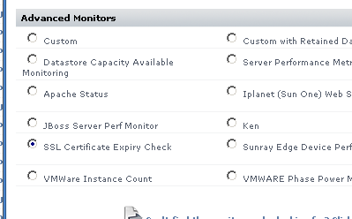

- Configure the target URL,url. Example https://myserverURL:9999
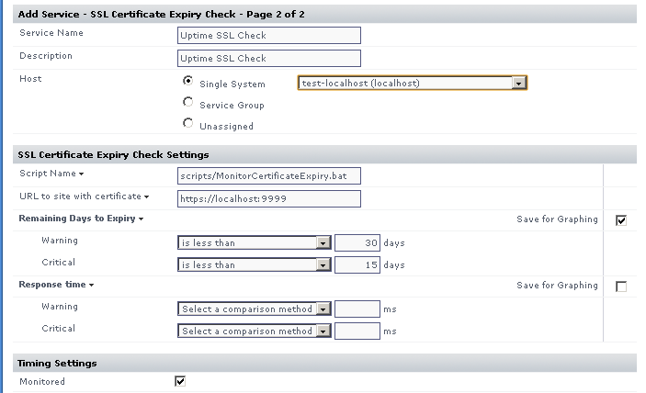

- Configure the monitor to threshold the number of days to warn, and the number of days to critical as shown above (the example shows warn at 30 days, critical at 15 days).

Note: If you are unsure what this means please immediately contact technical support or solutions engineering for assistance and guidance.

- Save the service monitor, find it on the list of services under “View Service Instances”
- click edit service instance for the new service monitor and click “test service instance”

you should see the following kind of output, notice that it says status: OK if your certificate is not expired. In the example below the certificate has been expired on this particular server for 2944 days. (hence the negative value)

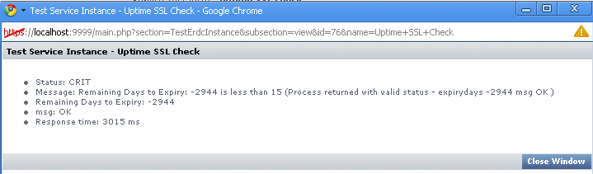

- You have now successfully configured the Expired SSL Certificate Monitor for up.time.

Troubleshooting

- I do not get any number of days from the scripts
  - Ensure the CURL is enabled in all instances of the php.ini that could affect the script

To be expanded/amended based on client feedback, please send your feedback to ken.cheung@uptimesoftware.com

Doc Revision History

Revision/Date | Author | Description
1.0 / 11.18.2008 | Ken Cheung | Creation and review

